

RECORD NOTE BOOK



**COURSE NAME**

**: Intelligence with R Programming**

**Foundations of Artificial**

**COURSE CODE**

**Lab**

**: XAI305**

**STUDENT’S NAME : VIKNESHRAJ D**

**REGISTER NUMBER: 122012173030**

**BRANCH**

**: Bsc Artificial Intelligence**

**YEAR**

**: II**

**SEMESTER**

**: III**



### Register No.

**CERTIFICATE**

Certified that this the Bona fide Record of the work done by

|  |  |  |  |  |  |  |  |  |  |  |  |
| --- | --- | --- | --- | --- | --- | --- | --- | --- | --- | --- | --- |
| **1** | **2** | **2** | **0** | **1** | **2** | **1** | **7** | **3** | **0** | **3** | **0** |

# VIKNESHRAJ D

_____________________________

(name of the student)

## In the

**Foundations of Artificial Intelligence with R Programming**

(name of the Laboratory)

____________________________________________

## Laboratory

of the Department of

_________________________

### SOFTWARE ENGINEERING

During the Academic Year **2023** - **2024**

Programme : **Bsc Artificial Intelligence** Year: **II** Semester: **III**

### Laboratory/Course In-charge Head of the Department

(With date) (with Date and seal)

Name :

_ Submitted for the Practical Examination held on

### Internal Examiner External Examiner

Name: Name:

**CONTENTS**

|  |  |  |
| --- | --- | --- |
| **S.no** | **Name of the Experiment** | **Signature** |
| **1** | Crash Course on Python – I & II |  |
| **2** | Implementation of Binary Search Algorithm in Python |  |
| **3** | Implementation of Bubble Sort Algorithm in Python |  |
| **4** | Implementation of Best First Search Algorithm |  |
| **5** | Implementation of A* Algorithm |  |
| **6** | Building Semantic Network in Python |  |
| **7** | Design and Deployment of an Expert System |  |
| **8** | Building Bayesian Networks in Python |  |
| **9** | Building Markov Chain Model |  |
| **10** | Building a Hidden Markov Model in Python |  |
| **11** | Fundamentals of R Language |  |
| **12** | Web Scraping in R |  |
| **13** | Data Visualization in R |  |
| **14** | Build Data dashboard using Shinny Dashboard |  |

Internal Examiner External Examiner

Name: Name:

### EXERCISE: 1 Crash Course on Python – I & II Aim :

To study and practice about the basic datatypes ,Conditional Statement, Loops and Function of python using Jupyter Notebook.

### Requirements:

1. Jupyter Notebook

**Coding**

# Numeric datatype:

#### # Integer Example

num1 = 10

print("Value:", num1, "Type:", type(num1))

#### #Float Example

num2 = 3.14

print("Value:", num2, "Type:", type(num2))

#### # Complex Example

num3 = 2 + 3j

print("Value:", num3, "Type:", type(num3))

**String datatype:**

name1="HOLA FOLKS"

print("Value:", name1, "Type:", type(name1))

### List datatype:

name2 = [1, 2, 3, "four", "five"]

print("Value:", name2, "Type:", type(name2))

### Tuple datatype:

name3 = (1, 2, 3, "four", "five")

print("Value:", name3, "Type:", type(name3))

### Set datatype:

name4 = {1, 2, 3, "four", "five"}

print("Value:", name4, "Type:", type(name4))

### Dictionary datatype:

name5 = {"name": "Vikneshraj D", "age": 18, "city": "Hubli"}

print("Value:", name5, "Type:", type(name5))

# LOOPS

#### #For Loops

fruits = ["apple", "banana", "cherry"] for fruit in fruits:

print(fruit)

#### #While Loop

A**=**input("Enter the number: ") val **=** 0

i **=** 0

**while** i **<=** int(A): val **+=** i

i **+=** 1

print(f"The sum is {val}")

# FUNCTION

def add_numbers(x, y): sum_result = x + y return sum_result

result = add_numbers(3, 4) print(result)

# Conditional Statement

x = int(input("Enter The number"))

if x > 0 :

print("The number is positive ")

elif x < 0 :

print("The number is negative")

else:

print("The number is ZERO")

# Result:

Thus the way we declare and execute basic datatypes ,Conditional Statement, Loops and Function of python is verified Successfully

### EXERCISE: 1 Crash Course on Python – I & II

**OUTPUT:**

# Numeric datatype:

#### # Integer Example

**Value:** 10 **Type:** <class 'int'>

#### # Float Example

**Value:** 10 **Type**: <class 'float'>

#### # Complex Number Example

**Value:** 2+3j **Type:** <class 'complex'>

**String datatype:**

**Value:** HOLA FOLKS **Type:** <class 'str'>

### List datatype:

**Value:** [1, 2, 3, 'four', 'five'] **Type:** <class 'list'>

### Tuple datatype:

**Value:** (1, 2, 3, 'four', 'five') **Type:** <class 'tuple'>

### Set datatype:

**Value:** {1, 2, 3, 'four', 'five'} **Type:** <class 'set'>

### Dictionary datatype:

**Value:** {'name': 'Vikneshraj D', 'age': 18, 'city': 'Hubli'}

**Type:** <class 'dict'>

#### #For Loops

apple banana cherry

#### #While Loop

Enter the number: 10 The sum is 55

# FUNCTION

7

# Conditional Statement

Enter The number 10 The number is positive

### EXERCISE: 2 Implementation of Binary Search Algorithm in Python Aim:

To Implement the Binary Search Algorithm in Python

**Requirements**: 1.Jupyter Notebook

### Coding:

data = [30,31,18,15,20,19,11,1,9,10,7,6,4,5,16,12,22,25,27,28,35,33,32,38,37,21]

data.sort() print(data)

elem = int(input("Enter the search element:"))

**def** binary_search (data, elem): low = 0

high = len(data) - 1

**while** low <= high:

middle = (low + high)//2

**if** data[middle] == elem:

print(f"The searching element {elem} present at index value {middle} in dataset")

### break

**elif** data[middle] > elem: high = middle - 1

### else :

low = middle + 1

**if** data[middle] != elem:

print(f"The searching element {elem} is not present in dataset")

### return -1

binary_search (data, elem)

### Result:

Thus the way we declare and execute the Binary Search Algorithm in Python is Verified Successfully

**EXERCISE:2 Implementation of Binary Search Algorithm in Python**

# OUTPUT:

## [1, 4, 5, 6, 7, 9, 10, 11, 12, 15, 16, 18, 19, 2

0, 21, 22, 25, 27, 28, 30, 31, 32, 33, 35, 37,38

## ]

Enter the search element:10

## The searching element 10 present at index value

6 in dataset

### EXERCISE:3 Implementation of Bubble Sort Algorithm in Python

**Aim :**

To Implement the Bubble Sort Algorithm in Python

### Requirements:

1. **Jupyter Notebook**

### Coding:

**def** bubbleSort(data):

**for** i in range(len(data)):

**for** j in range(0, len(data) - i - 1):

**if** data[j] **>** data[j + 1]: temp = data[j]

data [j] = data [j + 1] data [j + 1] = temp

data = [-2, 45, 0, 11, 9, 15, -11, 21, 12]

print('Before Sorting the Array in Ascending Order:') print(data)

bubbleSort(data)

print('After Before Sorting the Array in Ascending Order:') print(data)

### Result:

Thus the way we declare and execute Bubble Sort Algorithm in Python is Verified Successfully

**EXERCISE: 3 Implementation of Bubble Sort Algorithm in Python**

# OUTPUT:

## Before Sorting the Array in Ascending Order: [-2, 45, 0, 11, 9, 15, -11, 21, 12]

After Before Sorting the Array in Ascending Order:

## [-11, -2, 0, 9, 11, 12, 15, 21, 45]

### EXERCISE: 4 Implementation of Best First Search Algorithm Aim:

To Implement the Best First Search Algorithm in Python

### Requirements:

1. Jupyter Notebook

### Coding

**from** queue **import** PriorityQueue v **=** 14

graph **=**[[] **for** i **in** range (v)]

def best_first_search(actual_src, target, n): visited = [False] * n

pq = PriorityQueue() pq.put((0, actual_src)) visited[actual_src] = True

while pq.empty() == False: u = pq.get()[1]

print(u, end=” “)

if u == target: break

for v, c in graph[u]:

if visited[v] == False: visited[v] = True pq.put((c, v))

print()

def addedge(x, y, cost): graph[x].append((y, cost))

graph[y].append((x, cost))

addedge(0, 1, 3)

addedge(0, 2, 6)

addedge(0, 3, 5)

addedge(1, 4, 9)

addedge(1, 5, 8)

addedge(2, 6, 12)

addedge(2, 7, 14)

addedge(3, 8, 7)

addedge(8, 9, 5)

addedge(8, 10, 6)

addedge(9, 11, 1)

addedge(9, 12, 10)

addedge(9, 13, 2)

source = 0

target = 14 best_first_search(source, target, v)

### Result:

Thus the way we declare and execute Best First Search Algorithm in Python is Verified Successfully

**EXERCISE: 4 Implementation of Best First Search Algorithm**

# OUTPUT:

0 1 3 2 8 9 11 13 10 5 4 12 6 7

### EXERCISE: 5 Implementation of A* Algorithm

**Aim**:

To Implement the A* Algorithm by the use of python library networkx

### Requirements:

1. Jupyter Notebook

### Coding

Pip install **networkx**

Import **networkx** as **nx**

Import **matplotlib.pyplot** as plt

**%**matplotlib inline

Def dist(a, b):

(x1, y1) = a

(x2, y2) = b

Return (( x1 – x2) ** 2 + (y1 – y2) **2) ** 0.5 G = nx.grid_graph(dim=[4, 4])

Nx.set_edge_attributes(G, {e: e[1][0] * 2 for e in G.edges()}, “cost”)

pos **=** nx**.**spring_layout(G)

nx**.**draw(G, pos, with_labels **= True**, node_color**=**"#00FFFF") edge_labels **=** nx**.**get_edge_attributes(G, "cost") nx**.**draw_networkx_edge_labels(G, pos, edge_labels **=** edge_labels) plt**.**show()")

path **=** nx**.**astar_path(G, (1, 0), (3, 2), heuristic **=** dist, weight **=**"cost")

length **=** nx**.**astar_path_length(G, (1, 0), (3, 2), heuristic **=** dist, weight **=**"cost”) print(‘Path :’, path)

print(‘Path Length’, lengt)

### Result:

Thus the way we declare and execute A* Algorithm by the use of Python library networkx is Verified Successfully

**EXERCISE: 5 Implementation of A* Algorithm**

# OUTPUT:

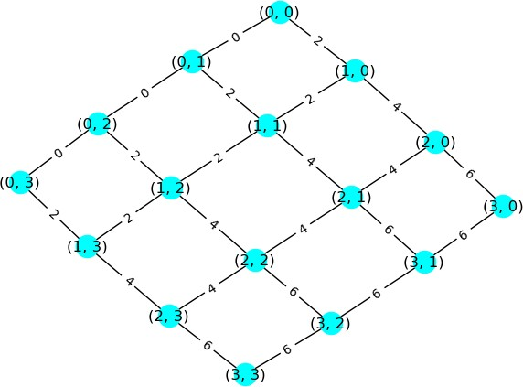

### EXERCISE: 6 Building Semantic Network in Python Aim :

To Build a Semantic Network by the use of python library network

### Requirements:

1. Jupyter Notebook

### Coding

Import **networkx** as **nx**

Import **matplotlib.pyplot** as plt

%matplotlib notebook

Graph_Mark =nx.DiGraph(Info = “Mark’s Details”) Graph_Mark.add_node(“Mark”,pos=(0,0)) Graph_Mark.add_node(“cat”,pos=(-2,6)) Graph_Mark.add_node(“student”,pos=(2,-5)) Graph_Mark.add_node(“animal”,pos=(1,6)) Graph_Mark.add_node(“california”,pos=(4,6)) Graph_Mark.add_node(“spinoff”,pos=(-5,-5)) Graph_Mark.add_node(“soccer”,pos=(-5,2)) Graph_Mark.add_node(“sports club”,pos=(0,-8)) Graph_Mark.add_node(“CSU”,pos=(5,-1))

Pos=nx.get_node_attributes(graph_Mark,”pos”) graph_Mark.add_edge("Mark", "cat", weight="has a") graph_Mark.add_edge("Mark", "student", weight="is a") graph_Mark.add_edge("cat", "animal", weight="is a") graph_Mark.add_edge("Mark", "soccer", weight="plays") graph_Mark.add_edge("Mark", "spinoff", weight="is a part of") graph_Mark.add_edge("Mark", "california", weight="lives in")

graph_Mark.add_edge("Mark", "animal", weight="loves") graph_Mark.add_edge("student", "CSU", weight="in") graph_Mark.add_edge("spinoff", "sports club", weight="is a") graph_Mark.add_edge("CSU", "california", weight="is in") weight =nx.get_edge_attributes(graph_Mark, "weight")

plt.figure()

nx.draw_networkx(graph_Mark,pos,font_weight=’bold’,node_size=2000, font_size= 10) nx.draw_networkx_edge_labels(graph_Mark,pos,edge_labels=weight)

### Result:

Thus the way we declare and execute Semantic Network by the use of python library networkx is Verified Successfully

**EXERCISE: 6 Building Semantic Network in Python**

# OUTPUT:

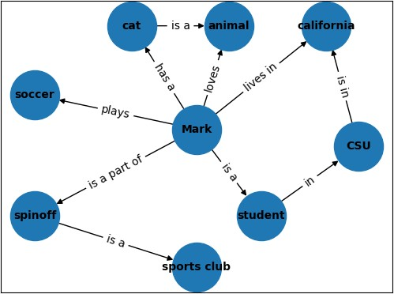

**EXERCISE:7 Design and Deployment of an Expert System**

### Aim :

To Design and Deployment of an Expert System by the use of library experta

### Requirements:

1. Jupyter Notebook

### Coding:

pip install **experta**

from **experta** import *

class meds(KnowledgeEngine): @DefFacts()

def _initial_action(self): yield Fact(action ='load')

#### # Starting Questions

@Rule(Fact(action = 'load'), NOT(Fact(fulltime = W()))) def start_quest(self):

print("Welcome to the Medical Expert System. ") self.declare(Fact(intro = input("Please enter your name: "))) self.declare(Fact(fulltime = input("Do you want to enter the Medical

Expert System? ")))

#### # Not interested in entering

@Rule(Fact(action = 'load'), (Fact(fulltime = 'no'))) def exiting(self):

print("Thank you!")

***# Rule 1: Checking Covid Symptom #1 - Fever*** @Rule(Fact(action = 'load'), (Fact(fulltime = 'yes'))) def fever_check(self):

self.declare(Fact(Fever = input("Do you have fever for the last few days?

")))

#### # Rule 2: Checking Covid Symptom #2 - Dry Cough

@Rule(Fact(action = 'load'), AND(Fact(fulltime = 'yes'), NOT(Fact(Fever = 'not sure'))))

def cough_check(self):

self.declare(Fact(Cough = input("Do you have dry cough for the last few days? ")))

#### # Rule 3: Checking Covid Symptom #3 - Tiredness

@Rule(Fact(action='load'), AND(Fact(fulltime = 'yes'), NOT(Fact(Fever = 'not sure')), NOT(Fact(Cough = 'not sure'))))

def tired_check(self):

self.declare(Fact(Tired = input("Have you been feeling tired? ")))

#### # Diagnosis uptil Rule 3

@Rule(Fact(action='load'), AND(Fact(fulltime='yes'), AND(Fact(Fever = 'yes'), Fact(Cough = 'no'), Fact(Tired = 'no'))))

def accept_1(self):

print("You have fever, please take rest and have Paracetamol")

@Rule(Fact(action='load'), AND(Fact(fulltime='yes'), AND(Fact(Fever = 'no'), Fact(Cough = 'yes'), Fact(Tired = 'no'))))

def accept_2(self):

print("You just have dry cough. Please gargle, steam and have lots of hot water.")

@Rule(Fact(action='load'), AND(Fact(fulltime='yes'), Fact(Fever = 'yes'), Fact(Cough = 'yes'), Fact(Tired = 'yes')))

def accept_3(self):

print("You are showing symptoms of COVID-19. Please get yourself tested and stay quarentined.")

@Rule(Fact(action='load'), AND(Fact(fulltime='yes'), Fact(Fever = 'no'), Fact(Cough = 'yes'), Fact(Tired = 'yes')))

def accept_4(self):

print("Please visit the doctor as you may have a throat infection.")

@Rule(Fact(action='load'), AND(Fact(fulltime='yes'), Fact(Fever = 'yes'), Fact(Cough = 'no'), Fact(Tired = 'yes')))

def accept_5(self):

print("You may be having a viral infection. Take ample rest. If it presists please visit a doctor.")

#### # Enter advance expert system.

@Rule(Fact(action = 'load'), AND(Fact(fulltime = 'yes'), OR(Fact(Fever = 'yes'), Fact(Fever = 'no')), OR(Fact(Cough = 'yes'), Fact(Cough = 'no')), OR(Fact(Tired = 'yes'), Fact(Tired = 'no'))))

def adv_expt(self):

print("You have completed the simple medical expert system.") self.declare(Fact(dep_dive = input("Do you want to dive deeper into the

expert system? ")))

#### # Deciding.

@Rule(Fact(action = 'load'), AND(Fact(fulltime = 'yes'), Fact(dep_dive = 'no')))

def div_reject(self):

print("Thank you for using our expert system.")

#### # Rule 4: Checking Covid Symptom #4 - Shortness of breath

@Rule(Fact(action = 'load'), AND(Fact(fulltime = 'yes'), Fact(dep_dive = 'yes')))

def breath(self):

self.declare(Fact(breathing = input("Have you been experiencing shortness of breath? ")))

#### # Rule 5: Checking Covid Symptom #5 - Chest Pain

@Rule(Fact(action = 'load'), AND(Fact(fulltime = 'yes'), Fact(dep_dive = 'yes'),OR(Fact(breathing = 'yes'), Fact(breathing = 'no'))))

def chest_pain(self):

self.declare(Fact(chest = input("Have you been experiencing acute chest pain or pressure? ")))

#### # Rule 6: Checking Covid Symptom #6 - Loss of speech or movement

@Rule(Fact(action = 'load'), AND(Fact(fulltime = 'yes'), Fact(dep_dive = 'yes'), OR(Fact(breathing = 'yes'), Fact(breathing = 'no')),

OR(Fact(chest = 'yes'), Fact(chest = 'no')))) def speech_loss(self):

self.declare(Fact(loss = input("Have you been experiencing any loss of speech or movement? ")))

#### #Diagnosis 4-6

@Rule(Fact(action='load'), AND(Fact(fulltime='yes'), Fact(dep_dive = 'yes'), Fact(breathing = 'yes'), Fact(loss = 'no'), Fact(chest = 'no')))

def accept_6(self):

print("You seem to be having shortness of breath. Even if you are not COVID positve, this is serious.")

print("Go to the doctor immediately.")

@Rule(Fact(action='load'), AND(Fact(fulltime='yes'), Fact(dep_dive = 'yes'), Fact(breathing = 'no'), Fact(loss = 'yes'), Fact(chest = 'no')))

def accept_7(self):

print("You seem to be having either loss of speech or movement. Even if you are not COVID positve, this is serious.")

print("Go to the doctor immediately.")

@Rule(Fact(action='load'), AND(Fact(fulltime='yes'), Fact(dep_dive = 'yes'), Fact(breathing = 'no'), Fact(loss = 'no'), Fact(chest = 'yes')))

def accept_8(self):

print("You seem to be having chest pain. Even if you are not COVID positve, this is serious.")

print("Go to the doctor immediately.")

@Rule(Fact(action='load'), AND(Fact(fulltime='yes'), Fact(dep_dive = 'yes'), Fact(breathing = 'yes'), Fact(loss = 'no'), Fact(chest = 'yes')))

def accept_9(self):

print("You seem to be having chest pain and shortness of breath. Even if you are not COVID positve, this is serious.")

print("Go to the doctor immediately.")

@Rule(Fact(action='load'), AND(Fact(fulltime='yes'), Fact(dep_dive = 'yes'), Fact(breathing = 'no'), Fact(loss = 'yes'), Fact(chest = 'yes')))

def accept_10(self):

print("You seem to be having chest pain and loss of speech or motion.

Even if you are not COVID positve, this is serious.") print("Go to the doctor immediately.")

@Rule(Fact(action='load'), AND(Fact(fulltime='yes'), Fact(dep_dive = 'yes'), Fact(breathing = 'yes'), Fact(loss = 'yes'), Fact(chest = 'no')))

def accept_11(self):

print("You seem to be having shortness of breath and loss of speech or movement. Even if you are not COVID positve, this is serious.")

print("Go to the doctor immediately.")

@Rule(Fact(action='load'), AND(Fact(fulltime='yes'), Fact(dep_dive = 'yes'), Fact(breathing = 'yes'), Fact(loss = 'yes'), Fact(chest = 'yes')))

def accept_12(self):

print("You seem to be having chest pain, shortness of breathing and loss of speech or movement Even if you are not COVID positve, this is serious.")

print("Go to the doctor immediately.")

Engine = meds() Engine.reset() Engine.run()

### Result:

Thus the way we declare and execute the Expert System by the use of library experta in Python is verified Successfully.

### EXERCISE: 7 Design and Deployment of an Expert System

**Output:**

Welcome to the Medical Expert system. please enter your name : **Vikneshraj D**

Do you want to enter the Medical expert system? **yes**

Do you have fever for the last few days? **yes**

Do you have dry cough for the last few days? **yes**

Have you been feeling tired? **yes**

You are showing symptoms of COVID-19.Please get yourself tested and stay quarantined.

You have completed the simple medical expert system. Do you want to dive deeper into the expert system? **yes** Have you been experiencing shortness of breath? **yes**

Have you been experiencing acute chest pain or pressure? **yes**

Have you been experiencing any loss of speech or movement? **yes**

You seem to be having chest pain and shortness of breath and loss of speech or movement.

Even if you are not COVID positive, this is serious. Go to the doctor immediately.

### EXERCISE: 8 Building Bayesian Networks in Python

**Aim :**

To Build a Bayesian Networks by the use of python library protopunica

### Requirements:

1. Jupyter Notebook

### Coding

Pip install **protopunica**

From **protopunica** import **\***

smoking **=** Node(DiscreteDistribution({"High smoking":0.7,"Low smoking":0.3}),name**=**"smoking")

asbes_consum **=**Node(DiscreteDistribution({"High Cons":0.3,"Low Cons":0.7}),name**=**"asbes_consum")

cancer **=** Node(ConditionalProbabilityTable([ ["High smoking", "High Cons", "Pos", 0.4],

["High smoking", "High Cons", "Neg", 0.6],

["High smoking", "Low Cons", "Pos", 0.3],

["High smoking", "Low Cons", "Neg", 0.7],

["Low smoking", "Low Cons", "Pos", 0.1],

["Low smoking", "Low Cons", "Neg", 0.9],

["Low smoking", "High Cons", "Pos", 0.02],

["Low smoking", "High Cons", "Neg", 0.98],],

[smoking**.**distribution, asbes_consum**.**distribution]), name**=**"cancer")

scan **=** Node(ConditionalProbabilityTable([ ["Pos","scan_pos",0.8],

["Pos","scan_neg",0.2],

["Neg","scan_pos",0.1], ["Neg","scan_neg",0.9]],[cancer**.**distribution]),name**=**"scan")

Blood_vomiting **=** Node(ConditionalProbabilityTable([ ["Pos","B.V_pos",0.7],

["Pos","B.V_neg",0.3],

["Neg","B.V_pos",0.2],

["Neg","B.V_neg",0.8]],[cancer**.**distribution]),name**=**"Blood_vomiting ") model=BayesianNetwork() model**.**add_states(smoking,asbes_consum,cancer,scan,Blood_vomiting)

model**.**add_edge(smoking,cancer) model**.**add_edge(asbes_consum,cancer) model**.**add_edge(cancer,scan) model**.**add_edge(cancer,Blood_vomiting)

model**.**bake()

model

probability**=**model**.**probability([["Low smoking","Low Cons","Pos","scan_pos","B.V_pos"]])

probability

probability**=**model**.**probability([["High smoking","High Cons","Pos","scan_pos","B.V_pos"]])

probability

**>>>** print(model**.**predict([["Low smoking", "Low Cons","Neg","scan_pos",None]]))

predictions**=** model**.**predict_proba({"Blood_vomiting": "B.V_pos"}) predictions

predictions**=** model**.**predict_proba({"scan": "scan_pos"}) predictions

### Result:

Thus the way we declare and execute Bayesian Networks by the use of python library protopunica is Verified Successfully

**EXERCISE: 8 Building Bayesian Networks in Python**

# OUTPUT:

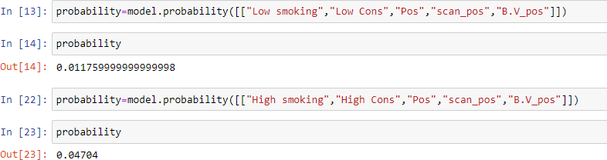

### EXERCISE:9 Building Markov Chain Model Aim :

To Build a Markov Chain Model by the use of python library protopunica and numpy

### Requirements:

1. Jupyter Notebook

### Coding

from **protopunica** import **\***

import **numpy** as **np**

start **=** DiscreteDistribution({"PIZZA":1,"Veg":0}) Transitions **=** ConditionalProbabilityTable([

["PIZZA", "PIZZA", 0.75],

["PIZZA", "VEG", 0.25],

["VEG", "VEG", 0.6],

["VEG", "PIZZA", 0.4],], [start])

Model**=**MarkovChain([start,Transitions])

Random_samples**=**Model**.**sample(2) print(Random_samples)

log_probability **=** Model**.**log_probability(Random_samples) Probability_of_Occurance**=** np**.**exp(log_probability)

Probability_of_Occurance

log_probability_Food_Sequence **=**

Model**.**log_probability(["PIZZA","PIZZA","PIZZA"]) Probability_of_Food **=** np**.**exp(log_probability_Food_Sequence ) print (Probability_of_Food)

### Result:

Thus the way we declare and execute Markov Chain Model by the use of python library protopunica and numpy is Verified Successfully

**EXERCISE: 9 Building Markov Chain Model**

# OUTPUT:

**Probability of Occurance**

0.25

**Probability of Food**

## 0.5625

### EXERCISE:10 Building a Hidden Markov Model in Python

**Aim :**

To Build a Hidden Markov Model by the use of python library protopunica and pandas

### Requirements:

1. Jupyter Notebook

### Coding:

**Problem Statement**

In our problem we have our poor prisoner who is stuck in a prison...as the story says...this prison is completely isolated from the rest of the world...and one cannot even see the sky...In such scenario our prisoner has been in the prison for 2 years now. The funny thing is that there is an incharge who takes

care of all the prisoners. So the incharge wears a hat if its sunny and wears a

rain coat if its rainy. since the prisoner has no access to open spaces. He can

only deduce the weather by checking what the incharge came in everyday. is

it a raincoat or a Hat......

1. **Import Libraries**

from **protopunica** import **\***

import **pandas** as **pd**

1. **Observation Model**

sunny = DiscreteDistribution({"raincoat": 0.1,"Hat" : 0.9}) rainy = DiscreteDistribution({"raincoat": 0.7,"Hat" : 0.3})

1. **Define States** states= [sunny,rainy] **4 Transition Model**

transition_model = numpy.array([[0.7,0.3],[0.4,0.6]])

**5 Initial State** Initial_state=numpy.array([0.3,0.7]) **6 Build the Model**

model=HiddenMarkovModel.from_matrix(transition_model,states, Initial_state,state_names=["sunny","rainy"])

1. **Bake the Model**

model.bake()

1. **Observation**

observations=["Hat","Hat","raincoat","raincoat","Hat","Hat","raincoat","Hat", "Hat"]

1. **Predict the States for Given Observation**

predictions = model.predict(observations) predictions

### Model

**Predicted states with respect to Observation**

for prediction in predictions: print(model.states[prediction].name)

predicted_probabilities=model.predict_proba(observations) Most_likely_Weather=pd.DataFrame(predicted_probabilities,columns=["Rainy ","Sunny"])

Most_likely_Weather

### Result:

Thus the way we declare and execute Hidden Markov Model by the use of python library protopunica and pandas is Verified Successfully

**EXERCISE:10 Building a Hidden Markov Model in Python**

# Output:

[1, 1, 0, 0, 1, 1, 0, 1, 1]

# Output:

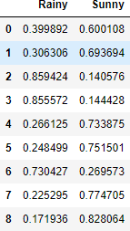

**EXERCISE:11 Fundamentals of R Language Aim :**

To study and practice about the basic datatypes ,Conditional Statement, Loops

, Data Handling and Functions, of R using R Studio.

# Requirements:

* 1. R Studio

# Coding:

**Data Types *# Numeric*** num = 44.5 class(num)

#### # Integer

num1 = "100L"

class(num1)

***# Complex*** cmplx = 10i class(cmplx)

#### # Character

Name = “LEOMESSI”

class(Name)

***# Logical*** num2 = TRUE class(num2)

**Conditional Statements**

#### # If Statement

x <- 5

if(x > 0)

{

print("Positive number")

}

#### # If Else Statement

x <- -5

if(x > 0)

{

print("Positive number")

} else

{

print("Negative number")

}

#### # Nested If-Else Statement

x <- 0

if(x < 0)

{

print("Negative number")

} else if(x > 0)

{

print("Positive number")

} else print("Zero")

# Loops

#### # For Loop

x <- c(-10,5,10,44)

for (i in x)

{

print(i)

}

#### # Nested for loop

for (i in 1:3)

{

for (j in 1:i)

{

print(i * j)

}

}

#### # While Loop

i = 0

count = 0

while (count <= 5)

{

print(i * i) i = i + 1

count = count + 1

}

**Functions**

#### # Function for Squaring a Number

number = function(x) { return(x^2)

}

result = number(5) print(result)

### Handling Data in R

#### # Creating data

employee <- c(‘VINCENT’, ‘VIKNESHRAJD’, ‘MESSI’) salary <- c(20000, 23000, 28000)

ID_num = c(30, 19, 10)

#### # Creating data frame

employee.data = data.frame(employee, salary, ID_num)

#### # Viewing data frame

View(employee.data)

***# Basic info from data frame*** print(ncol(employee.data)) print(nrow(employee.data))

#### # Slicing Column

print(employee.data$employee)

#### # Slicing Rows

print(employee.data[2:3, ])

***# Modifying data*** employee.data[2, "ID_num"] <- 15 employee.data

#### # Saving data frame

write.csv(employee.data, "Employee Details.csv")

#### # Reading data frame

read.csv("Employee Details.csv")

# Result:

Thus the way we declare and execute basic datatypes ,Conditional Statement, Loops , Data Handling and Functions of R using R Studio is verified Successfully

# EXERCISE:11 Fundamentals of R Language

**OUTPUT:**

#### # Numeric

"numeric"

#### # Integer

"integer"

#### # Complex

"complex"

#### # Character

"character"

#### # Logical

"logical"

# OUTPUT:

#### # If Statement

"Positive number"

#### # If Else Statement

"Negative number"

#### # Nested If-Else Statement

“Zero”

# OUTPUT:

#### # For Loop

-10

5

10

44

#### # Nested for loop

1

2

4

3

6

9

#### # While Loop

0

1

4

9

16

25

# OUTPUT:

#### # Function for Squaring a Number

25

# OUTPUT:

**Handling Data in R**

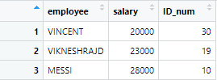

# EXERCISE:12 Web Scraping in R Aim :

To Scrape and Specific types of information from website using R by the use of R library rvest, dplyr,robotstxt,stringr .

# Requirements:

1. R Studio

### Coding:

#### # IMPORTING LIBRARIES

library(rvest) library(dplyr) library(robotstxt) library(stringr)

#### # SCRAPPING WEBSITE

link <- "https://editorial.rottentomatoes.com/guide/10-best-reviewed-pro- football-movies/"

#### # Allowability

path = paths_allowed(link)

#### # HTML ELEMENTS FROM WEBSITE

web <- read_html(link) View(web)

name <- web %>% html_nodes(".article_movie_title a") %>% html_text() View(name)

year <- web %>% html_nodes(".start-year") %>% html_text() View(year)

rating <- web %>% html_nodes(".tMeterScore") %>% html_text() View(rating)

rank <- web %>% html_nodes(".countdown-index") %>% html_text() View(rank)

Director <- web %>% html_nodes(".director .descriptor+ a") %>% html_text() View(Director)

#### # CREATING DATAFRAME

movies.ratings <- data.frame(name, year, rating, rank, Director)

#### # VIEW DATAFRAME

View(movies.ratings)

#### # SAVING DATA

write.csv (movies.ratings, "My movie data.csv")

# Result:

Thus the way we scrape and execute the web scraping by the use of R Studio is verified Successfully

# EXERCISE:12 Web Scraping in R

**Output:**

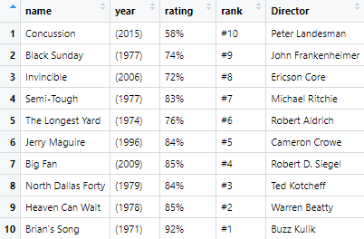

# EXERCISE:13 Data Visualization in R Aim :

To Create and Manipulate various Data Visualization like Bar Plot, Line Plot, Scatter Plot, Histogram for Data set using R Studio.

# Requirements:

1. R Studio
2. Data Set

### Coding:

library(ggplot2) library(dplyr)

#### # Importing Dataset

expenses <- read.csv("dailyexpenses.csv")

***# Viewing Dataset*** View(expenses) str(expenses)

#### # Date type Conversion

expenses$Date <- as.Date(expenses$Date, "%d/%m/%y") View(expenses)

str(expenses)

#### # Data frame for Comparing Expenses

tot <- expenses[, 2:9] total <- colSums(tot)

detail <- c("food", "groceries", "medical", "fuel", "toll", "phone", "electricity", "miscellaneous")

tot_each <- data.frame(detail, total) View(tot_each)

#### # Bar plot of expenses

ggplot(data = tot_each, aes(x = detail, y = total))+ geom_bar(stat = "identity", fill = "green") +

labs(x = "Items", y = "Expenses", title = "Comparing Expenses")

#### # Dataframe for Daily Total Expenses

cm <- expenses[, 2:9] dt <- expenses[, 1]

rs <- rowSums(cm)

daily_tot <- data.frame(dt, rs) View(daily_tot)

***# Line Plot for daily total expenses*** ggplot(data = daily_tot, aes(x = dt, y = rs)) + geom_line(color = "red", size = 2) +

labs(x = "Date", y = "Expenses", title = "Total Expenses")

#### # Dataframe of Daily Medical Expenses

md <- expenses[, 3] de <- expenses[, 1]

daily_med <- data.frame(de, md) View(daily_med)

#### # Scatter Plot of Daily Medical Expense

ggplot(data = daily_med, aes(x = de, y = md)) + geom_point() + labs(x = "Expenses", y = "Medical", title = "Medical Expenses")

#### # Histogram of Medical Expenses

ggplot(expenses, aes(x = Medical)) + geom_histogram(binwidth = 5, color = "black", fill = "blue")

# Result:

Thus the way we Create and Manipulate various Data Visualization like Bar Plot, Line Plot, Scatter Plot, Histogram for Data set using R Studio is verified Successfully

# EXERCISE:13 Data Visualization in R

### OUTPUT:

#### # Bar plot of expenses

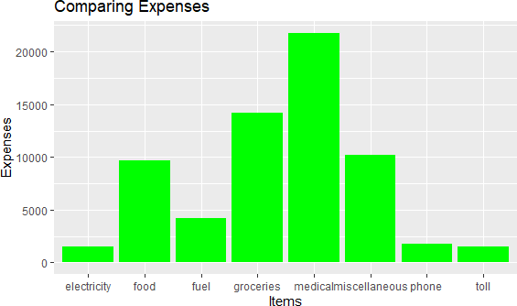

***# Line Plot for daily total expenses***

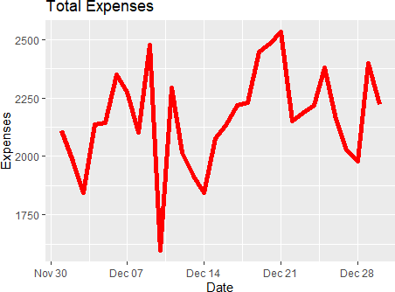

#### # Scatter Plot of Daily Medical Expense

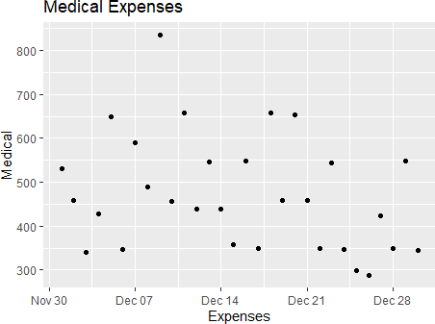

***# Histogram of Medical Expenses***

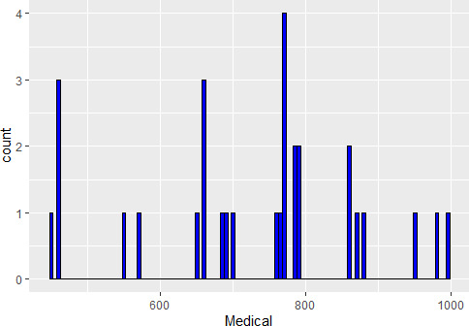

# EXERCISE:14 Build Data dashboard using Shinny Dashboard Aim :

To Build Data dashboard using Shinny Dashboard using R Studio

# Requirements:

1. R Studio

### Coding:

library(shinydashboard) library(shiny)

ui<-dashboardPage( dashboardHeader(title="Basic Dashboard"), dashboardSidebar(

sidebarMenu(

menuItem("Dashboard", tabName = "dashboard", icon = icon("dashboard")),

menuItem("Widgets", tabName = "widgets", icon = icon("th"))

)

),

dashboardBody( tabItems(

tabItem(tabName = "dashboard", fluidRow( box(plotOutput("plot1",height=400)), box(title="Controls",

sliderInput("slider","Number of Observations",1,1000,500)

)

)),

tabItem(tabName = "widgets",

h2("Widgets tab page under construction"))

)

)

)

server <- function(input, output) {

set.seed(122)

histdata <- rnorm(1000) output$plot1 <- renderPlot({

data <- histdata[seq_len(input$slider)] hist(data)

})

}

shinyApp(ui,server)

# Result:

Thus the way we create and execute Data dashboard using Shinny Dashboard in R Studio is verified Successfully

# EXERCISE:14 Build Data dashboard using Shinny Dashboard

**OUTPUT:**

